Agent Tool Use and RAG — Lesson Plan
Classification: UNCLASSIFIED

1. Administrative and metadata

1.1 Lesson title
Agent Tool Use and RAG

1.2 Module length
60 minutes (1 hours)
Schedule slot is 60 minutes. Content-guide ~75-90 minutes is the longer lecture narrative.

1.3 Terminal and enabling learning objectives
- TLO-5: At the end of the Counterstrike Operator Course, students will be able to use local inference and agentic workflows to support hunting and planning, and counter adversary agentic systems.
- ELO-83: Describe agentic workflow architecture (planner, tools, retrieval) in a mission context.
- ELO-84: Given access to workflow tooling, build and run an agentic workflow that uses tools and retrieval-augmented generation.

1.4 Prerequisites
- B04.M14: Agent Reinforcement

2. Personnel, range, and environment

2.1 Instructor and cadre
- 1 × instructor (required)
- 0 × range_engineer (not_applicable: Lecture Module; no range engineer required)
- 0 × auditor (not_applicable: Not used by this course)
- 0 × oversight_officer (not_applicable: Not used by this course)

2.2 Materials and resources
Instructor resources and pre-class preparation
- Classroom projector and screen; whiteboard for the opening contract
- Parent or sibling briefs listed in this Module folder
- Live tabs and references already named in this file's header
- Do not project flags, tokens, or answer-key values
Student resources and environment
- Student brief, student guide, or homework file in this Module folder when present
- Assigned range, workstation, or lab stack named in the student-facing file
- No extra kit beyond what the student-facing file already lists

3. Assessment and evaluation
ELO | Method | Related Module | Criteria
ELO-83 | in-class Q&A | — | In-class questions and check on learning in the content guide.
ELO-84 | in-class Q&A | — | In-class questions and check on learning in the content guide.

4. Instructional delivery

4.1 Opening, attention grabber, and motivator

Option 1 (Interactive / Whiteboard / Kinesthetic)
- Say: "You already built a workflow that could classify and export evidence. This hour we turn that workflow into an advisor. It reads the STIX-style incident output, retrieves doctrine, calls a controlled enrichment tool, and recommends an effect in the same vocabulary as disable, deceive, reconnoiter, and handoff. It does not execute the effect. It prepares a recommendation a human can review."
- Do: Put the lesson contract on the board. Keep products from the prerequisite Module available.
- Ask (Q): What would make you trust an automated recommendation enough to brief it?
- Expected Response (A): Facilitation. Use the Say/Do already on this row; do not force a single keyed answer.

Option 2 (Digital Slide / Virtual / Slide Deck)
- Say: "You already built a workflow that could classify and export evidence. This hour we turn that workflow into an advisor. It reads the STIX-style incident output, retrieves doctrine, calls a controlled enrichment tool, and recommends an effect in the same vocabulary as disable, deceive, reconnoiter, and handoff. It does not execute the effect. It prepares a recommendation a human can review."
- Show: The title slide and lesson objectives.
- Do: Confirm stations can open the required tool or file before the first teaching row.
- Ask (Q): What would make you trust an automated recommendation enough to brief it?
- Expected Response (A): Facilitation. Use the Say/Do already on this row; do not force a single keyed answer.

4.2 Side-by-side table of instruction
Visual / Slide Asset | Instructional Delivery & Instructor Notes
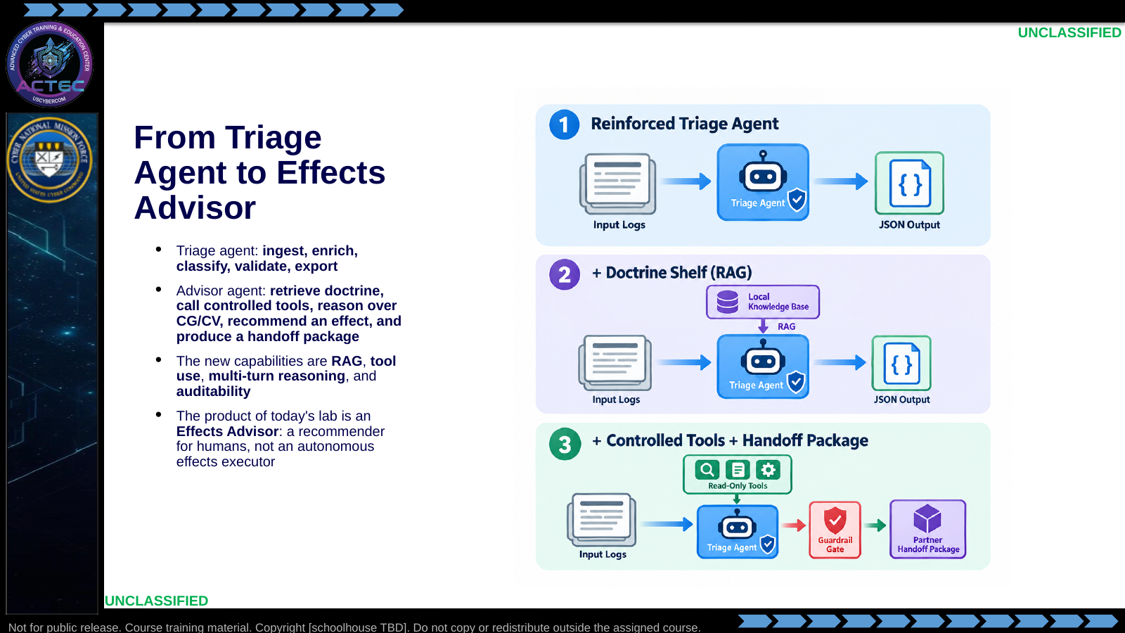  Slide 1: From Triage Agent to Effects Advisor  Duration: 6 min | Say: "You already built a workflow that could classify and export evidence. This hour we turn that workflow into an advisor. It reads the STIX-style incident output, retrieves doctrine, calls a controlled enrichment tool, and recommends an effect in the same vocabulary as disable, deceive, reconnoiter, and handoff. It does not execute the effect. It prepares a recommendation a human can review."  Show: The three-stage evolution and point out that triage output is advisor input.  Do: Ask: "What would make you trust an automated recommendation enough to brief it?" Capture answers under evidence, citations, guardrails, and audit trail.  Ask (Q): What would make you trust an automated recommendation enough to brief it?  Expected Response (A): Facilitation. Use the Say/Do already on this row; do not force a single keyed answer.
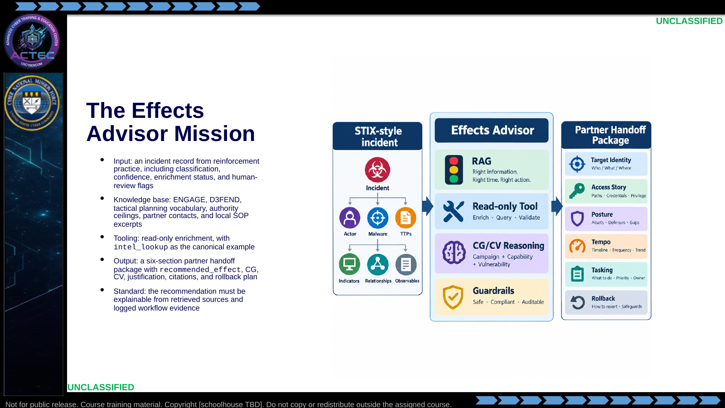  Slide 2: The Effects Advisor Mission  Duration: 6 min | Say: "The mission is not 'ask the model what to do.' The mission is to compress analyst staff work: read the incident, consult doctrine and partner context, enrich one observable, reason in CG/CV language, and produce a handoff package that a human can accept, modify, or reject."  Show: The six-section output path and the specific recommended_effect field.  Do: Have students name which skills supply each part of the mission: effect vocabulary, handoff package, incident schema, and RAG/tools.  Ask (Q): What is the operational takeaway from this row?  Expected Response (A): Facilitation. Restate the Say/Do in operator terms. Do not invent a new teaching point.
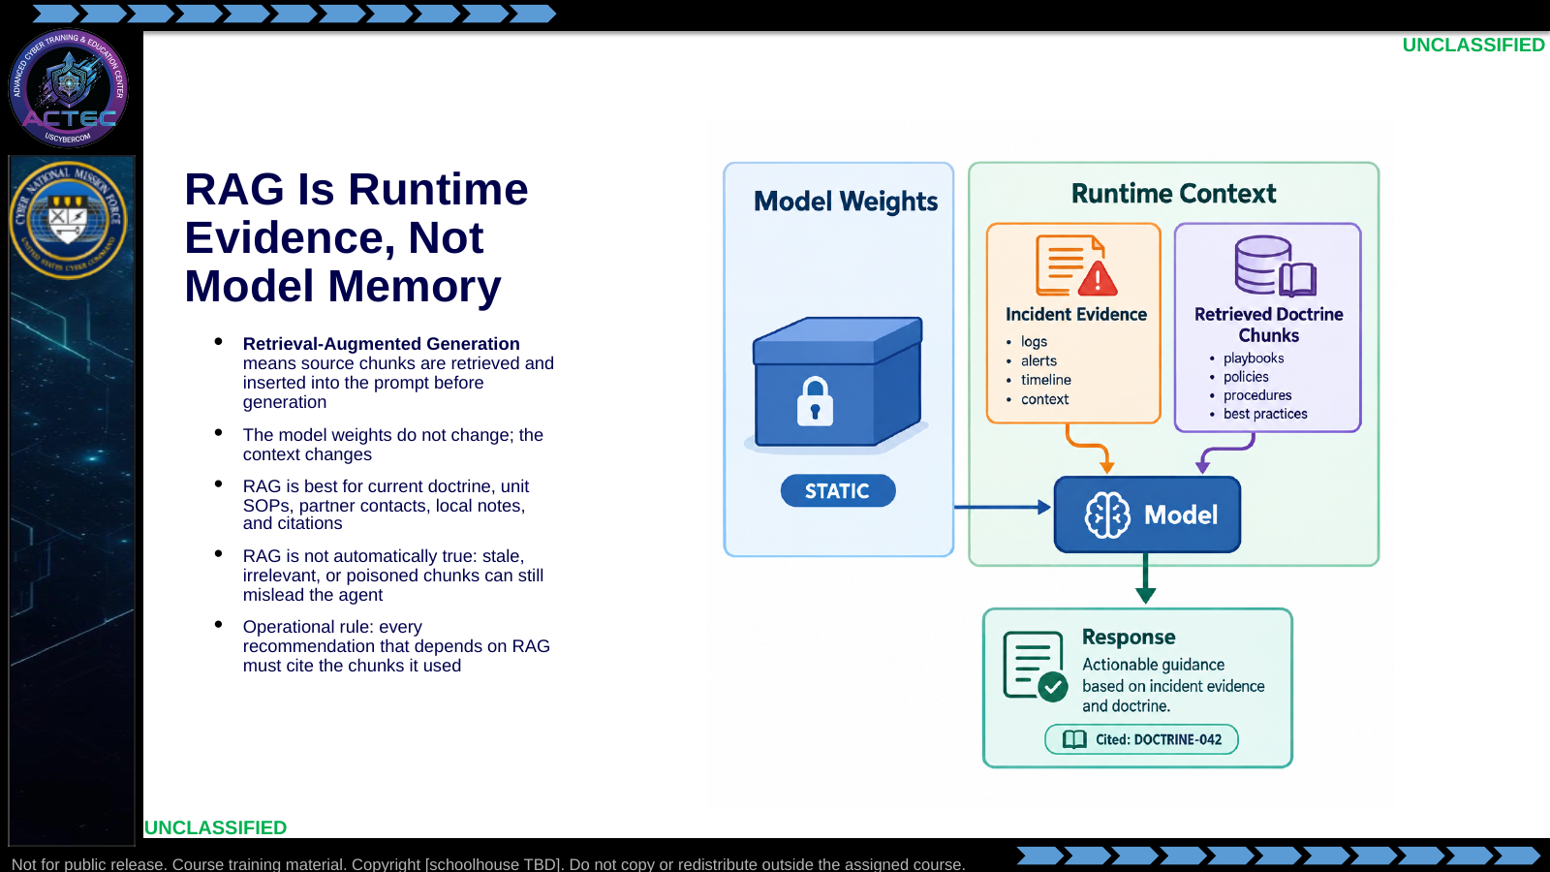  Slide 3: RAG Is Runtime Evidence, Not Model Memory  Duration: 6 min | Say: "RAG does not teach the model new facts permanently. It gives the model an open book during this run. That is powerful because the book can be local and current. It is also dangerous because a bad book produces confident bad answers."  Show: Contrast static model weights with dynamic retrieved context.  Do: Ask: "If the model cites a source chunk, does that make the answer correct?" Drive toward: citations make it reviewable, not automatically correct.  Ask (Q): If the model cites a source chunk, does that make the answer correct?  Expected Response (A): citations make it reviewable, not automatically correct
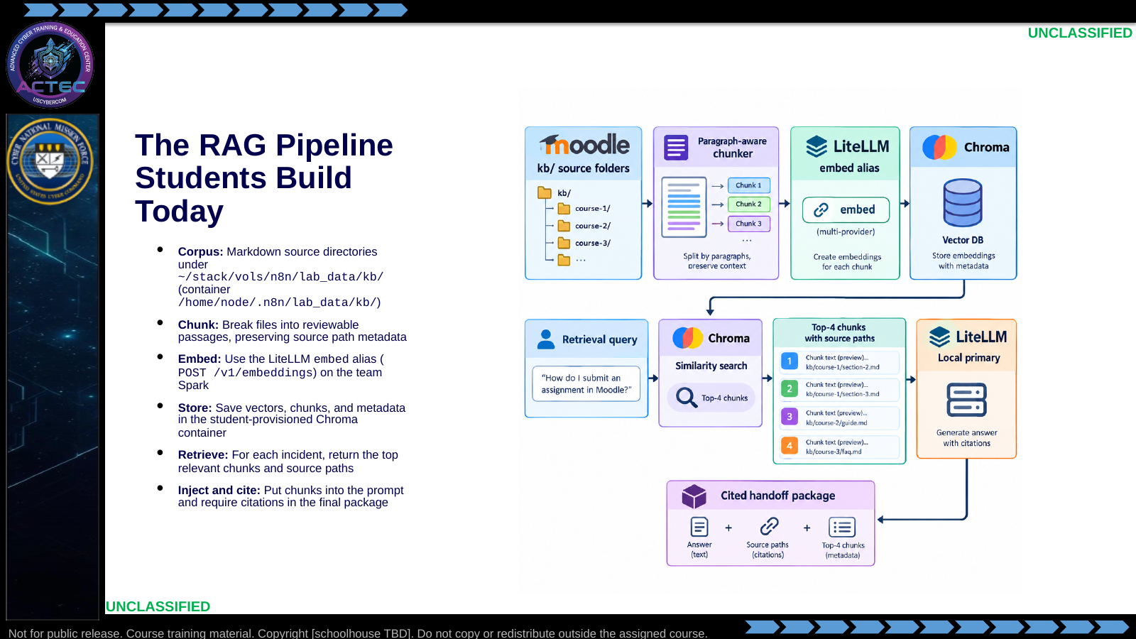  Slide 4: The RAG Pipeline Students Build Today  Duration: 6 min | Say: "This is the build sequence. Corpus, chunk, embed, store, retrieve, inject, cite. If students skip chunking and embed whole files, retrieval quality drops. If they lose source metadata, citations become useless. Every stage has to preserve reviewability."  Show: The pipeline and point at source metadata moving with each chunk.  Do: Ask students why a 500-token paragraph-aware chunk is usually better than one giant file or one sentence at a time.  Ask (Q): What is the operational takeaway from this row?  Expected Response (A): Facilitation. Restate the Say/Do in operator terms. Do not invent a new teaching point.
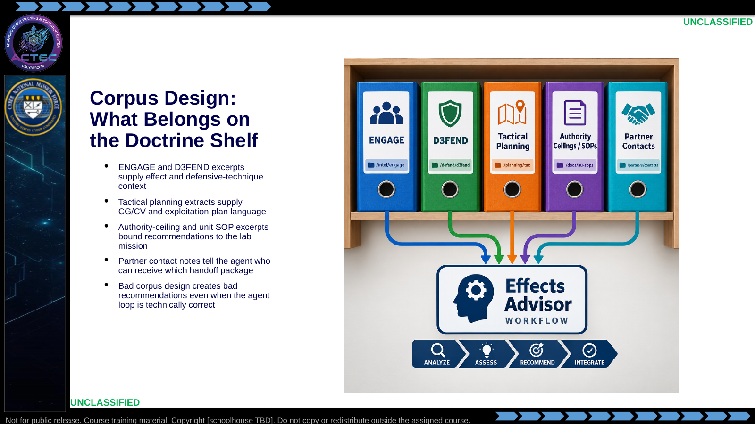  Slide 5: Corpus Design: What Belongs on the Doctrine Shelf  Duration: 6 min | Say: "The corpus is not a dumping ground. It is the advisor's reference shelf. If you add irrelevant documents, stale partner contacts, or doctrine with no source labels, you make the model harder to audit."  Show: The five corpus categories and tie each to a required field in the final output.  Do: Ask: "Which corpus source would help the agent avoid recommending an effect against a friendly mirrored system?" Expected answer: partner contacts and local context.  Ask (Q): Which corpus source would help the agent avoid recommending an effect against a friendly mirrored system?  Expected Response (A): partner contacts and local context
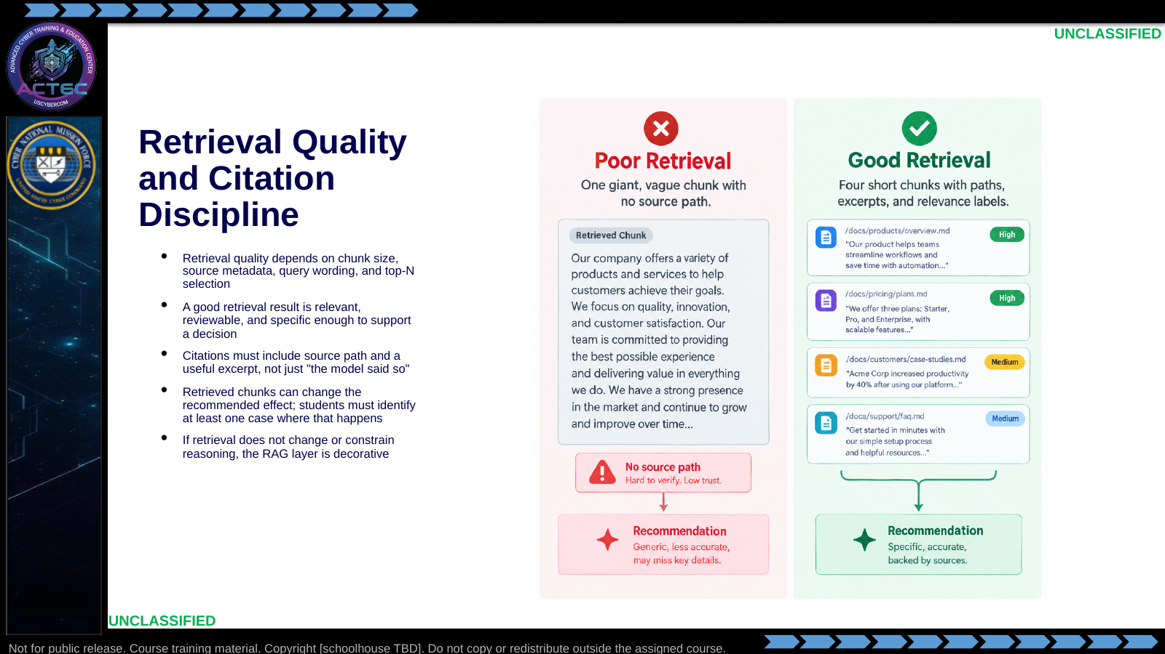  Slide 6: Retrieval Quality and Citation Discipline  Duration: 6 min | Say: "The point of RAG is not to make the prompt longer. The point is to add decision-useful evidence. If the retrieved chunks do not change the recommendation, constrain it, or support it with citations, then the agent is just doing free-text guessing with extra steps."  Show: Poor vs good retrieval examples.  Do: Have students name one field in the final handoff package that should be directly supported by a retrieved citation.  Ask (Q): What is the operational takeaway from this row?  Expected Response (A): Facilitation. Restate the Say/Do in operator terms. Do not invent a new teaching point.
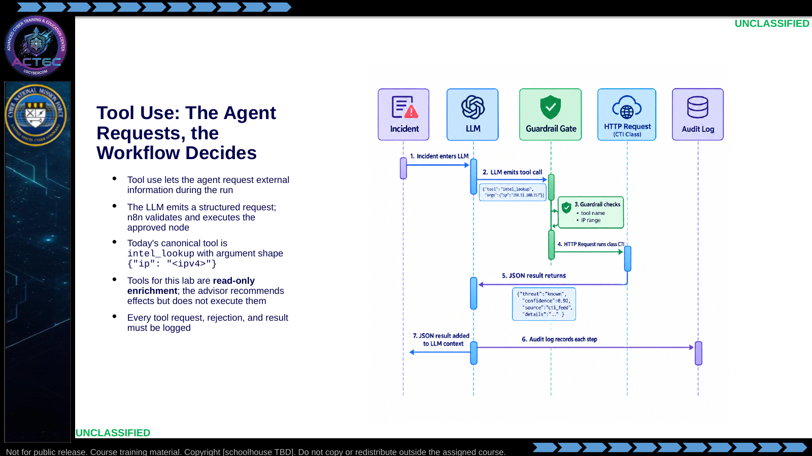  Slide 7: Tool Use: The Agent Requests, the Workflow Decides  Duration: 6 min | Say: "The model asks; the workflow decides. That distinction matters. If the model asks for a tool that is not approved, the workflow refuses. If the argument is malformed or out of range, the workflow refuses. Tool use is only safe when the orchestration layer is in charge."  Show: The sequence diagram and linger on the guardrail gate.  Do: Ask students why the Day 4 advisor is limited to read-only tools. Tie the answer back to human review and recommendation-only posture.  Ask (Q): What is the operational takeaway from this row?  Expected Response (A): Facilitation. Restate the Say/Do in operator terms. Do not invent a new teaching point.
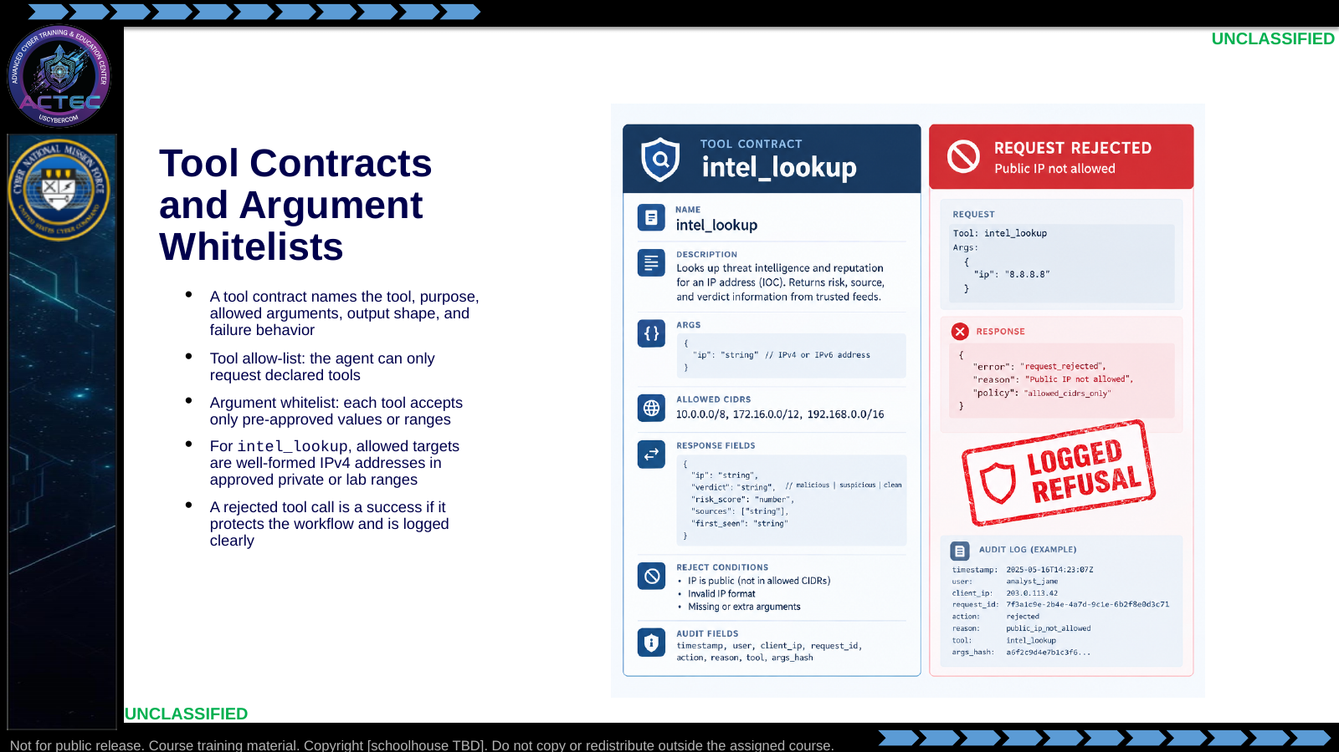  Slide 8: Tool Contracts and Argument Whitelists  Duration: 6 min | Say: "A tool without a contract is an invitation to misuse. The contract tells the model what the tool is for, but more importantly it tells the workflow what to accept and what to reject."  Show: The intel_lookup contract and an example of a rejected out-of-range request.  Do: Ask: "What should the workflow do if the agent asks to call http_fetch instead of intel_lookup?" Expected answer: reject, log, and continue or fail gracefully according to policy.  Ask (Q): What should the workflow do if the agent asks to call http_fetch instead of intel_lookup?  Expected Response (A): reject, log, and continue or fail gracefully according to policy
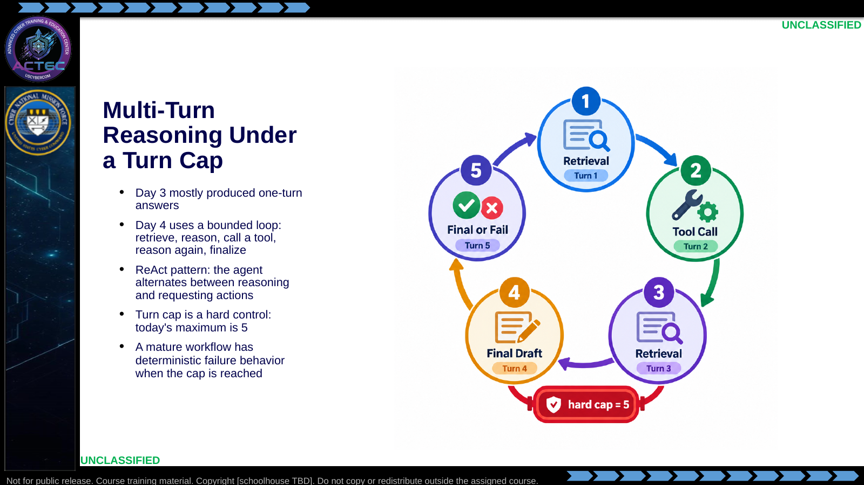  Slide 9: Multi-Turn Reasoning Under a Turn Cap  Duration: 6 min | Say: "Multi-turn reasoning is where agents become useful and where they become dangerous. A confused agent will keep asking the same question forever unless the workflow stops it. The cap is not a suggestion. It is part of the safety case."  Show: The five-turn loop and explain what an acceptable run looks like.  Do: Ask students what the final output should say if the cap is reached without a recommendation. Drive toward unresolved/human-review fallback, not silent failure.  Ask (Q): What is the operational takeaway from this row?  Expected Response (A): Facilitation. Restate the Say/Do in operator terms. Do not invent a new teaching point.
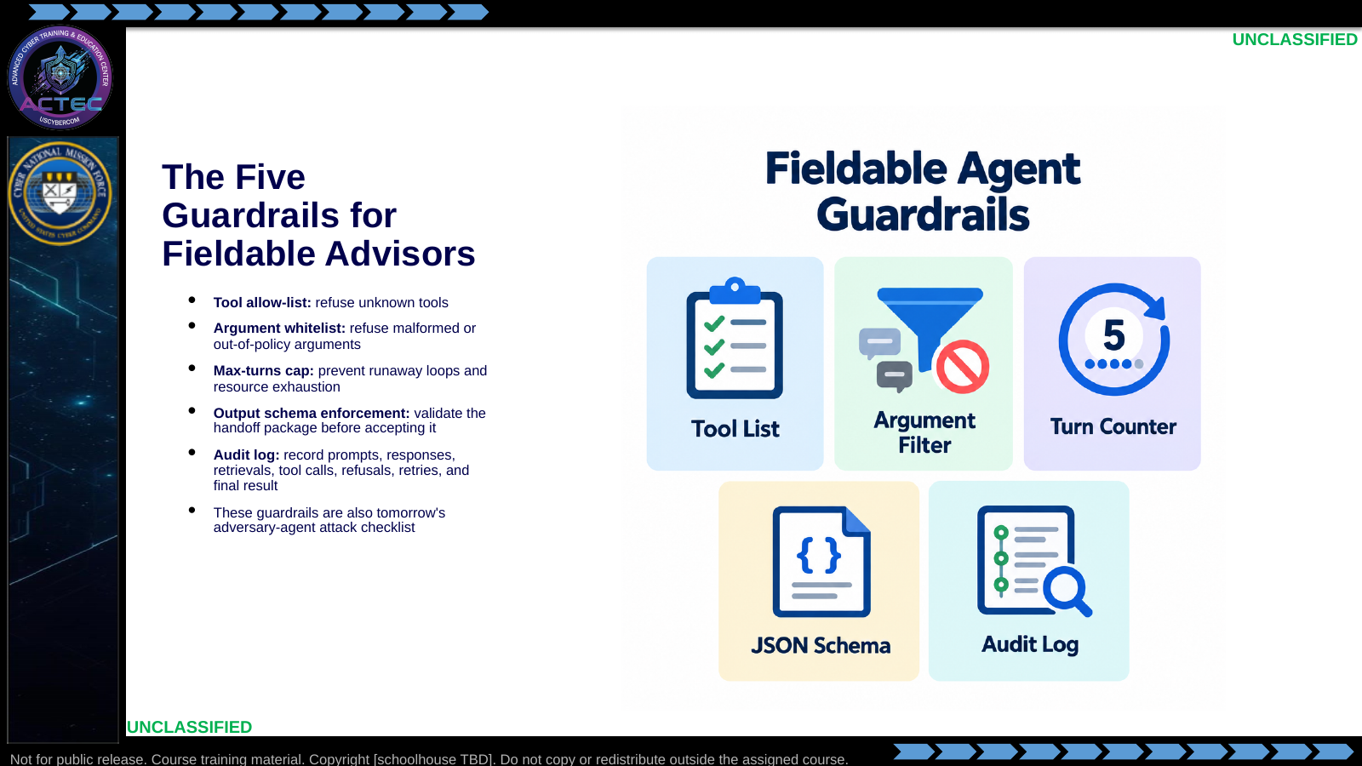  Slide 10: The Five Guardrails for Fieldable Advisors  Duration: 6 min | Say: "These five are the difference between a demo and something you can brief. They are also the bridge to tomorrow. On Day 5, you will look for an adversary agent that failed one or more of these controls."  Show: The five guardrails and explicitly connect each to a possible failure.  Do: Tell students today's grading checks guardrails as strictly as recommendation quality.  Ask (Q): What is the operational takeaway from this row?  Expected Response (A): Facilitation. Restate the Say/Do in operator terms. Do not invent a new teaching point.
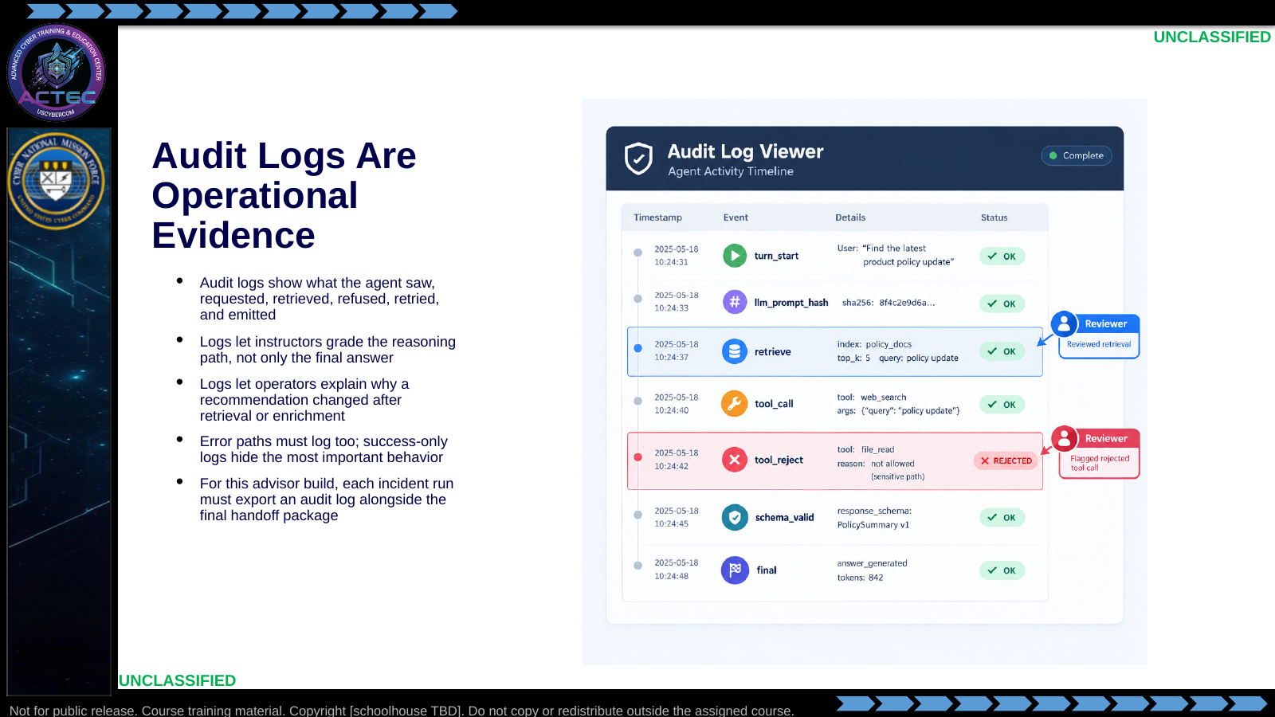  Slide 11: Audit Logs Are Operational Evidence  Duration: 6 min | Say: "The final JSON tells you what the agent recommended. The audit log tells you whether you should trust how it got there. A fluent answer with no audit trail is not operationally useful."  Show: Example audit events and tie them to the advisor-lab deliverables.  Do: Ask students which audit event would prove that retrieval changed an effect recommendation.  Ask (Q): What is the operational takeaway from this row?  Expected Response (A): Facilitation. Restate the Say/Do in operator terms. Do not invent a new teaching point.
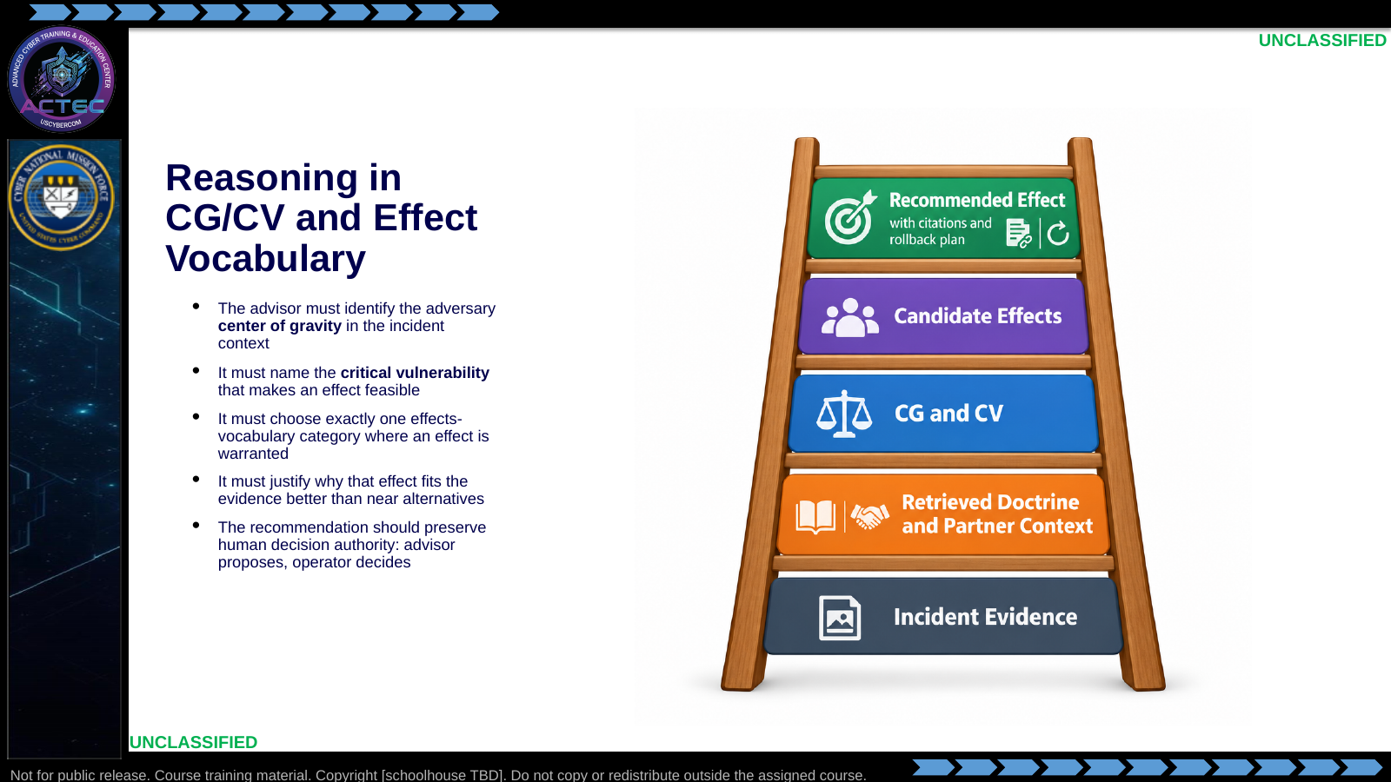  Slide 12: Reasoning in CG/CV and Effect Vocabulary  Duration: 6 min | Say: "The model is not allowed to invent a tenth effect category. It must reason inside the vocabulary you learned: deny, degrade, disrupt, destroy, deceive, manipulate, reconnoiter, interdict, handoff. That discipline is what makes the output comparable across teams."  Show: The reasoning ladder and point to where citations support CG/CV.  Do: Give a quick example: if evidence is ambiguous and needs_human_review is true, ask why reconnoiter may be stronger than deny.  Ask (Q): What is the operational takeaway from this row?  Expected Response (A): Facilitation. Restate the Say/Do in operator terms. Do not invent a new teaching point.
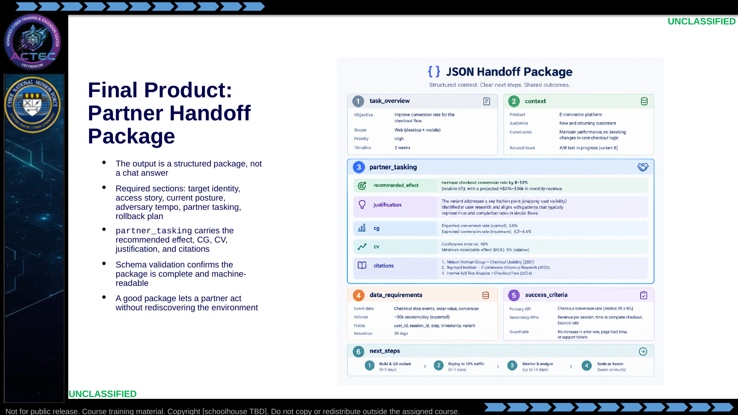  Slide 13: Final Product: Partner Handoff Package  Duration: 6 min | Say: "The Effects Advisor is valuable only if the output can move. A partner should be able to read the package, understand the target, see the evidence, know the recommended effect, and understand rollback. That is why schema matters."  Show: The six sections and tie them back to the handoff package.  Do: Ask students which section would fail first if the agent had no partner-contact corpus.  Ask (Q): What is the operational takeaway from this row?  Expected Response (A): Facilitation. Restate the Say/Do in operator terms. Do not invent a new teaching point.
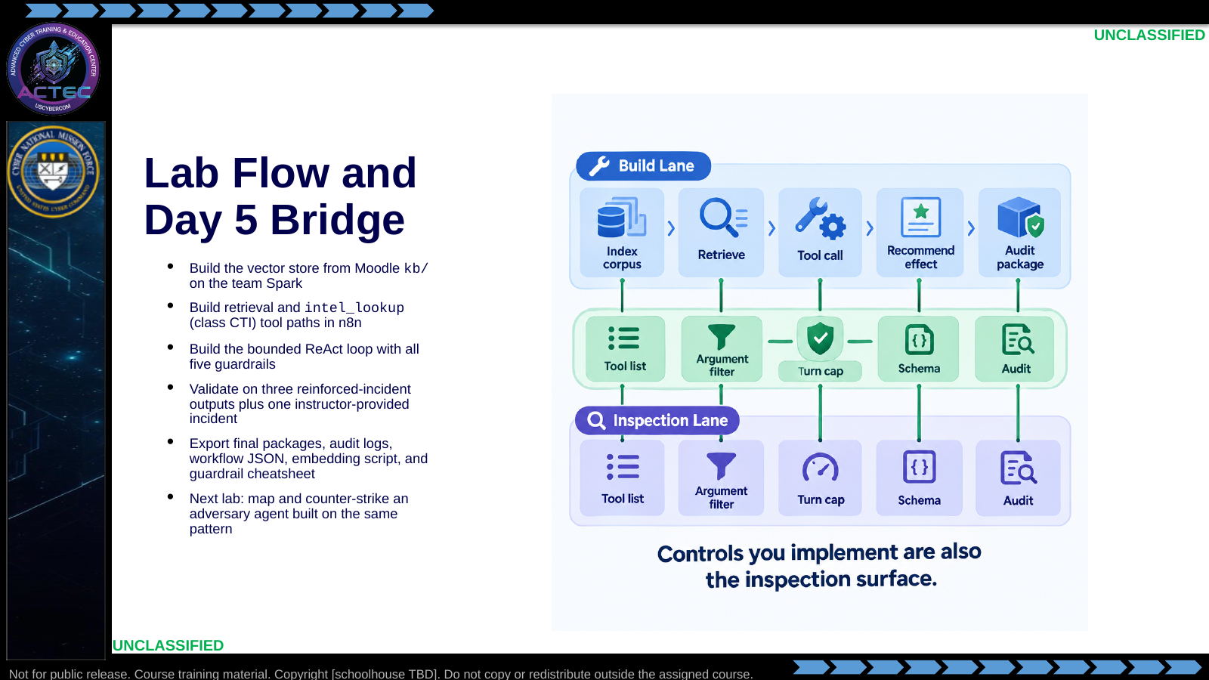  Slide 14: Lab Flow and Day 5 Bridge  Duration: 6 min | Say: "Today you build the architecture well. Tomorrow you hunt for where the adversary built it badly. The corpus, tools, loop, schema, and audit log you implement today become your target-analysis checklist tomorrow."  Show: The Day 4-to-Day 5 roadmap.  Do: Release to the Effects Advisor lab and remind students that the guardrail cheatsheet is not paperwork; it is the field guide for later adversary-agent work.  Ask (Q): What is the operational takeaway from this row?  Expected Response (A): Facilitation. Restate the Say/Do in operator terms. Do not invent a new teaching point.

4.3 Lesson summary
- B04.M15-agent-tool-use-rag is executed as a generated lesson plan from this file.
- Assessment methods live on module.yaml; do not invent extra official ELOs.
- Later practice in this Block continues from the product this session collects.

4.4 Questions and check on learning
- Ask (Q): What would make you trust an automated recommendation enough to brief it?
- Expected Response (A): Facilitation. Use the Say/Do already on this row; do not force a single keyed answer.
- Ask (Q): What is the operational takeaway from this row?
- Expected Response (A): Facilitation. Restate the Say/Do in operator terms. Do not invent a new teaching point.
- Ask (Q): If the model cites a source chunk, does that make the answer correct?
- Expected Response (A): citations make it reviewable, not automatically correct

5. Classification
Classification: UNCLASSIFIED

